ADVENT CANDLE SERVICE
The Light of the World

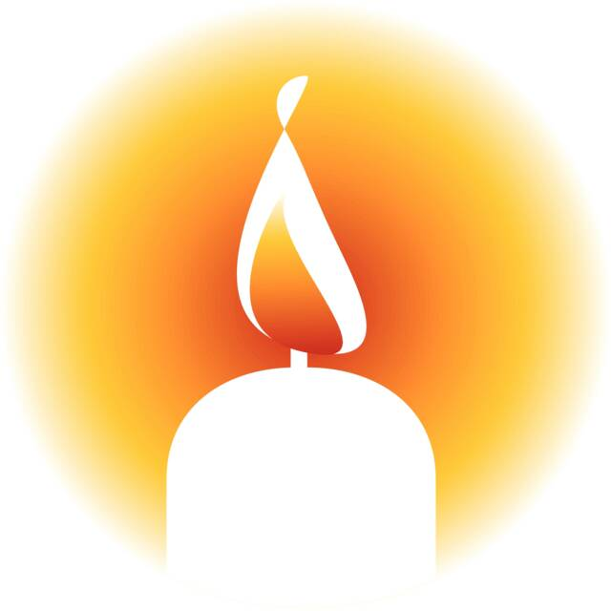
4.00 p.m.
DATE?
Church ?
Welcome & Introduction (lights are dimmed)
Welcome to our Advent Candle Service which focuses on Christ the Light of the World and his call to each one of us to be light in the world too.

Hymn Longing for Light
Longing for light, we wait in darkness.
Longing for truth, we turn to you.
Make us your own, your holy people,
Light for the world to see.

Christ, be our light! Shine in our hearts.
Shine through the darkness.
Christ, be our light!
Shine in your church gathered today.

Longing for peace, our world is troubled.
Longing for hope, many despair.
Your word alone has power to save us.
Make us your living voice.

Chorus

Longing for food, many are hungry.
Longing for water, many still thirst.
Make us your bread, broken for others,
Shared until all are fed.

Chorus

Longing for shelter, many are homeless.
Longing for warmth, many are cold.
Make us your building, sheltering others,
Walls made of living stone.

Chorus
1
Many the gifts, many the people,
Many the hearts that yearn to belong.
Let us be servants to one another,
Making your kingdom come.

Christ, be our light! Shine in our hearts.
Shine through the darkness.
Christ, be our light!
Shine in your church gathered today.

Reading: Light your People by John Harvey (adapted)

Lord Jesus,
We thank you
that when the world was very dark
You came to bring light into darkness.

You came in the night
to bring light into the lives
of Mary and Joseph.
You came to Bethlehem –
then, as now, a very troubled town –
bringing light to all
who came to trust you.

You come to us now,
into our lives
and into our world,
bringing light still to your people.

We ask you now once again
to accept this worship that we bring
this Advent tide .....

Help us to see
the light that will shine for us,
not just at Christmas
but every day of the year.
2
Special intention – in the light of God

When this world is as dark as night,
You are the one we call the Light. (light 1st candle on Advent wreath)
Come, Lord Jesus.

When we are tempted to go astray,
You are the one we call the Way. (light 2nd candle on Advent wreath)
Come, Lord Jesus.

When the storms of life increase,
You are the one we call our Peace. (light 3rd candle on Advent wreath)
Come, Lord Jesus.

When troubles to our lives bring harm,
You are the one who brings us calm. (light 4th candle on Advent wreath)
Come, Lord Jesus.

Reading: A Thought by Ruth Burgess

Dust
Stardust
Everything made of it

Rocks
Trees
Elephants
Plankton

Stardust

You
Me
Jesus
All of us
stardust

Twinkle
Twinkle

Wow
3
The Sharing of the Light

Jesus said,
“I am the light of the world.
Whoever follows me
Will not walk in darkness,
But have the light of life.”

Reflection on Holman Hunt`s “The Light of the World.”

As each person passes the light to another:
The light of Christ.

As each person receives the light from another:
Thanks be to God.
Choir Anthem This Little Light of Mine
Prayers
Let us pray. When I say “Lord Jesus,” please respond: “Bring Light.”
Lord Jesus, Bring Light.

Jesus, You are the light of the world.
Shine in the dark places where there are wars
and where people hurt each other......

Lord Jesus,
Bring Light.

Jesus, You are the light of the world.
Help our leaders to know how to run this country
so that everybody`s needs are met,
especially those who are suffering.

Lord Jesus,
Bring Light.
4
Jesus, you are the light of the world.
Shine in the dark places
where people are ill or sad or dying....
in a time of quiet we hold them
in your love ....

Lord Jesus,
Bring Light.

Jesus,
We are your lights in the world.
Help us to show people your light by loving them.

Lord Jesus,
Bring Light.

Jesus,
We are your lights in the world.
Help us to put the needs of others
before our own needs for your sake.

Lord Jesus,
Bring Light.

Jesus,
We are your lights in the world.
Help us to look out for you and to listen out for you
so we can follow you in everything we do.

Lord Jesus,
Bring Light.

5

Closing Responses

Now as we blow out our candles
Stay with us God.
Stay with us God.

As we say goodbye to each other,
Stay with us God.
Stay with us God.

As we travel homewards,
Stay with us God.
Stay with us God. Amen.

Hymn Lord the Light of your love is shining

Lord, the light of your love is shining,
In the midst of the darkness, shining;
Jesus, light of the world, shine upon us;
Set us free by the truth you now bring us,
Shine on me, shine on me.
Shine, Jesus, shine,
Fill this land with the Father's glory;
Blaze, Spirit, blaze,
Set our hearts on fire.
Flow, river, flow,
Flood the nations with grace and mercy;
Send forth your word,
Lord, and let there be light!

Lord, I come to your awesome presence,
From the shadows into your radiance;
By the blood I may enter your brightness,
Search me, try me, consume all my darkness.
Shine on me, shine on me.

Shine, Jesus, shine, etc.
6
As we gaze on your kingly brightness
So our faces display your likeness.
Ever changing from glory to glory,
Mirrored here may our lives tell your story.
Shine on me, shine on me.

Shine, Jesus, shine, etc.
Closing Prayer

Light of God
Lead us.

Power of God
Hold us.

Joy of God.
Heal us.

Laughter of God
Bless us.

Love of God.
Caress us.

Now and always. Amen.

Acknowledgments
Materials adapted from “Hay & Stardust” by Ruth Burgess © Wild Goose Publications 2007 & “The Bumper Book of Resources Advent Christmas Epiphany” Ed. by John Cox © Kevin Mayhew 2015

7

