Lammas-tide Service
A service of thanksgiving for the first fruits of the harvest
Followed by light refreshments
Sunday 4th August 6:00 pm
St George’s Church, Modbury, PL21 0QN
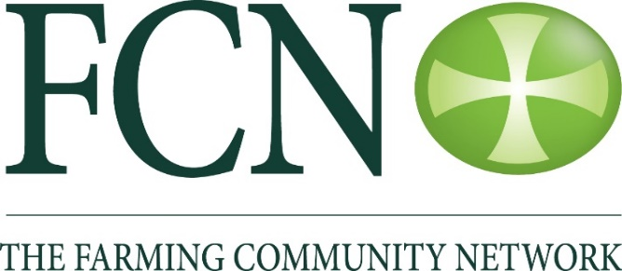
Talk by: Rev M Rowland

